

Amazon and Adobe Partnership

Hi Amazonians,

It has been yet another incredible year working closely with you all at Amazon, and we want to express my heartfelt gratitude for the strong and amazing partnership we have built together. Over the years, we have not only worked as partners but also grown to become great friends. As we approach the festive season, we hope that you have happy holidays filled with peace, love, and happiness.

To continue nurturing our collaboration, we will be sending out quarterly newsletters. These newsletters will highlight our joint success stories, provide you with the latest news and events, and share something personal from our journey together. We aim to keep them both informative and engaging, ensuring they bring value to you.

Thank you for your unwavering support and collaboration. Looking forward to many more years of success together!

AEP is on AWS

Adobe and Amazon Web Services (AWS) have expanded their partnership to bring the Adobe Experience Platform (AEP) to AWS. This collaboration enables brands to enhance customer engagement through precise personalization and AI-driven insights, offering a unified view of customers across channels. With applications like Adobe Real-Time CDP, Adobe Journey Optimizer, and Adobe Customer Journey Analytics, brands can create, engage, and analyze marketing content efficiently. The partnership provides brands with greater flexibility and scalability, leveraging AWS's robust cloud infrastructure for secure and seamless activation of customer insights! Learn more here.

News You Should Know

Meet Lisa Gorman  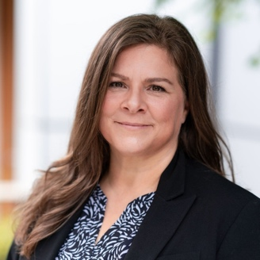  Lisa has held account sales, account management, practice management, digital product marketing, program management office and business and operations roles in DMR Consulting, Fujitsu Consulting, Telstra (Enterprise and Government), Slalom Consulting and most recently Starbucks, where she lead an organization responsible for managing the program delivery, financial management and business operations for the Customer and Retail Technology organization leading a team of 30+.  She is joining Adobe as your Global Account Director and is thrilled to meet you all! | Meet Scott Nedwick    Scott Nedwick is based in sunny California and brings years of executive leadership experience to the table. He has held key roles at companies such as Fond, where he served as VP of Sales and Customer Success, BrightEdge, where he was VP of Global Professional Services and Solution Consulting, and Reltio, where he was VP of Global Customer Success.  He has been with Adobe for a year as a Technical Account Director and is excited to collaborate with you all moving forward as your Ultimate Success Group Manager!
Upcoming Event: Adobe Summit

Adobe Summit is right around the corner hitting Las Vegas and online from March 18th-March 20th!
Join us to hear from the world’s top brands, connect with other leaders, and explore what’s next in generative AI and personalization at scale.
Here is the link to register for Adobe Summit 2025, and make sure to use code sS25TT1k8 to register for $1,695 up to the start of Summit! For more Summit information, check out your Adobe Summit Express Page.
We are also very excited for the Amazon Innovator Day taking place at The Wynn on Monday, March 17th from 12:00pm-5:00pm. There will also be a happy hour to follow!
This is an excellent opportunity to learn from your fellow Amazon peers and other speakers. You can expect awesome keynotes and presentations around Workfront Planning, AJO B2B with Marketo, Content Supply Chain, and more!
In addition, if you’re going to NRF in January- let us know! Adobe will be at NRF and would love to meet you there! We also have some awesome events to share.

Adobe Team Highlight

Lisa brings to us an understanding of defining and managing cross functional governance models, portfolio value management and realization, financial performance, and on-time delivery of a portfolio of digital customer experience programs worth > $200M per annum. She has experience in leading organizations through digital product engineering transformation and has personally designed and implemented a complimentary operating model for both the Program Management Office and the Business and Operations Office that integrates with all Enterprise-wide funding and portfolio value realization processes.

Lisa was born, raised, attended university, and started her career in the Pacific Northwest. She then spent 12 years living and working in Australia where she and her husband (an Aussie) still have a home and visit as often as they can. They have spent the past 12 years living in West Seattle with their dog, Herschel. Lisa loves the mountains and spends lots of her free time at her family’s cabin near Mt Rainier where she grew up. She also loves cooking, reading, gardening, music (playing and listening) and is constantly picking up new hobbies.

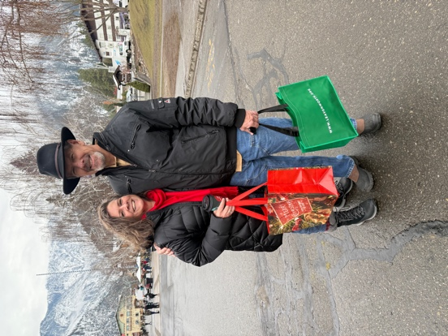

Adobe at re:Invent

This year, we had about 80 people from Adobe attend re:Invent… and we loved it! From the awesome key notes to the technical sessions to the exciting product launches, we are so excited to see the growth and developments of your teams.
We are also deeply honored to be acknowledged as a leading AWS Partner with the AWS Media & Entertainment Competency. Our team is committed to helping customers transform their lens-to-glass workflows across areas like Broadcast, Content Production, Direct to Consumer distribution, Media Supply Chain and Archive, and Data Science & Analytics for Media!
Feel free to check out this blog to learn more about how we are partnering to bring the Adobe Experience Platform to brands while enhancing customer engagement with deep insights.
Thank you for such an awesome conference experience!

Please note that your Adobe Account Team will be on Winter Shutdown from December 24th-January 2nd. If you submit any tickets, your TAMs will be able to support you! Thank you in advance, and happy holidays!

